FOD CHOICE

**Faculty** = Miss Sana Sheeraz

**Batch code** = 2011 G3

**Curriculum**= 6673,

**Semester**= HDSE II,



APTECH NORTH NAZIMABAD

http://www.aptechnn.com

**group members & enrolment no**.

HAFIZ MUHMMAD HAMZA (Student1287890)

ABDUR RAFAY KHAN

(Student1287896)

ABU HURAIRA KHAN

(Student1274240)



USER MANUAL

GUIDE



**This is intro screen when user open the application this screen will appear for the 7 to 8 sec….**

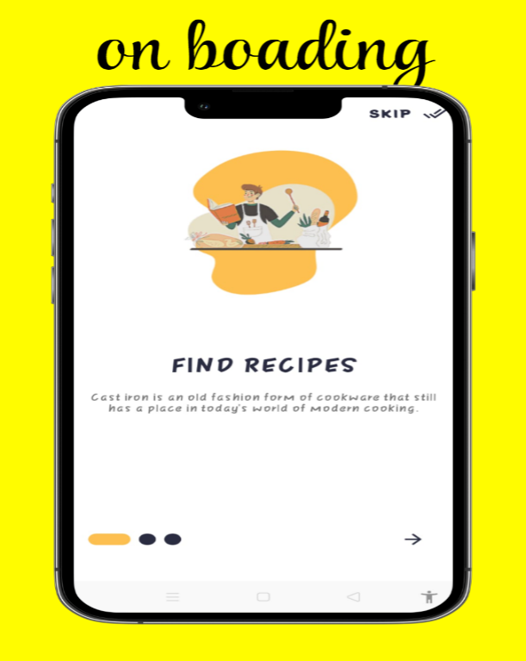

**This is onboarding screen. The screen will be visible for first time installation…**



**When user click close button it will automatic choose a guest mode account to see application…..**



**This button will redirect to Sign In Screen…**

**This button will redirect to Sign Up Screen…**



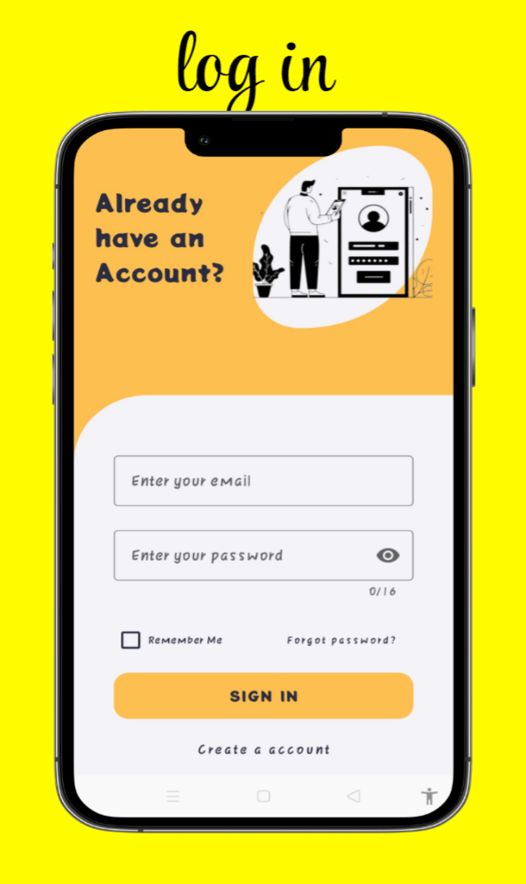

**If you have an account the sign in to the app.**

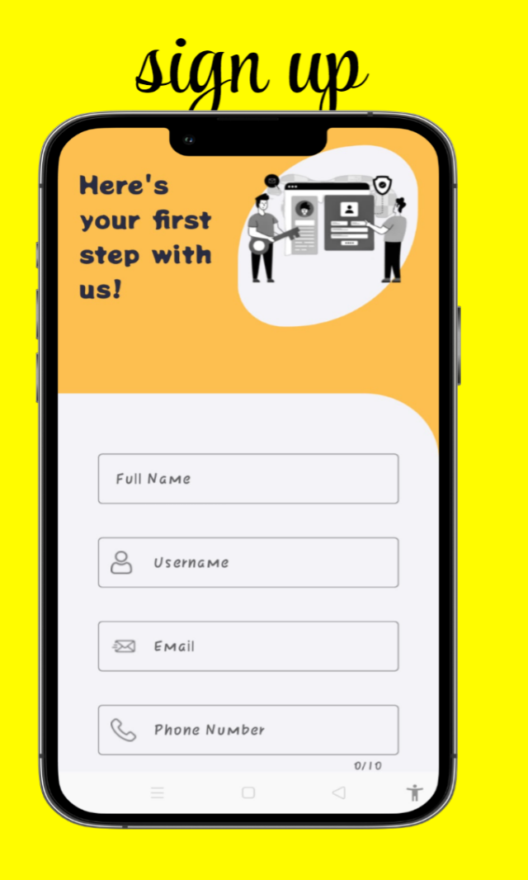

**If don’t have an account you can create a account .**

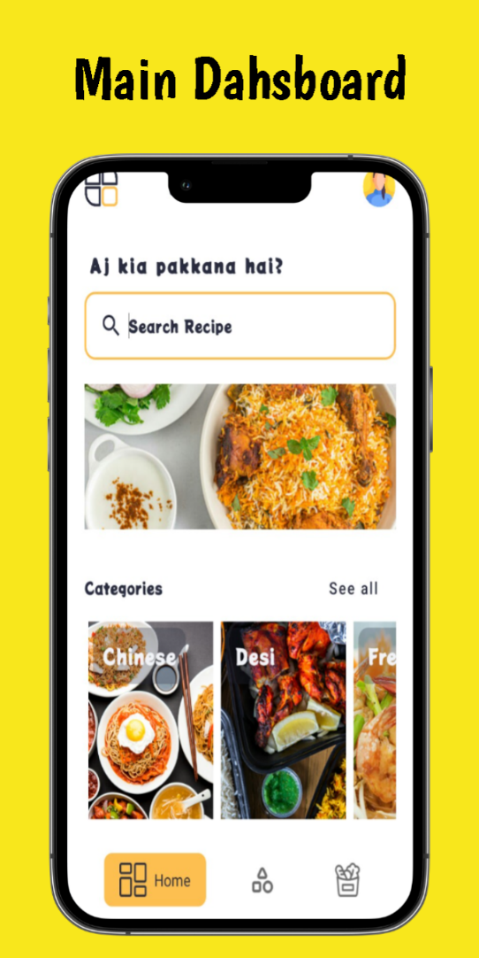

**This Main Screen where you can see different type of recipe’s , categories, Menu option etc**

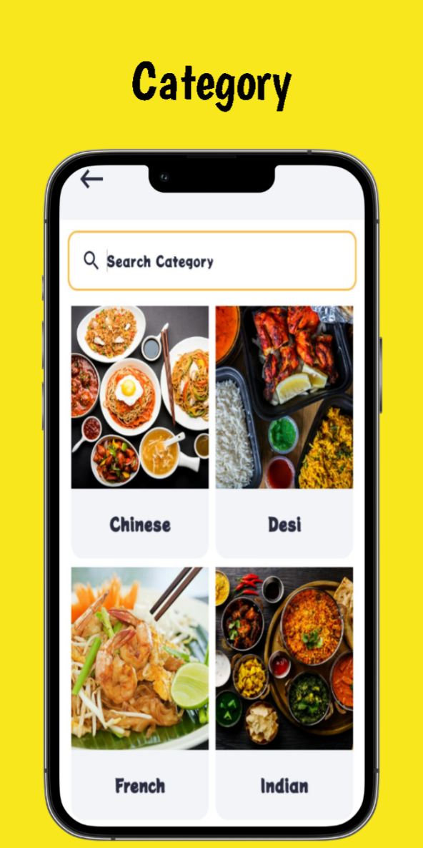

**Category screen you find any type of recipe**

**Of your favorite category.**

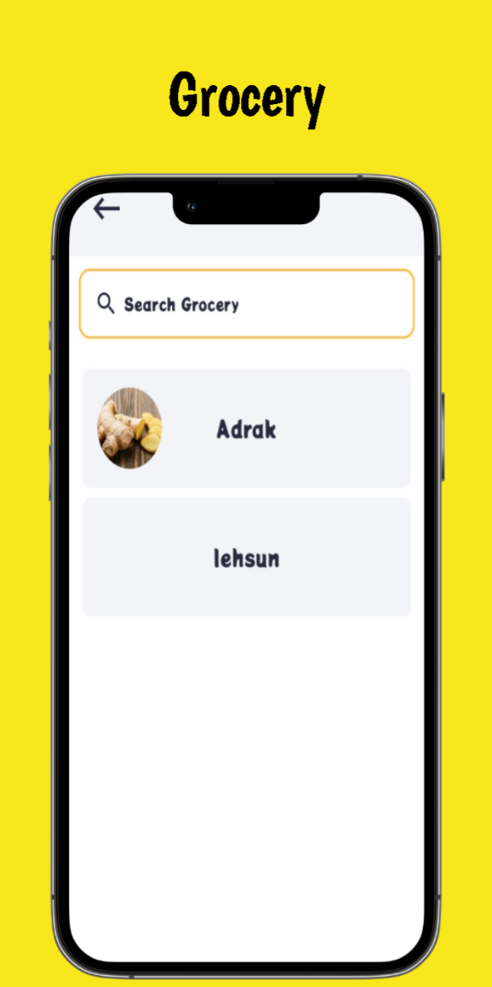

**Grocery screen shows the items in our database system that help you to create own recipe to select grocery items.**

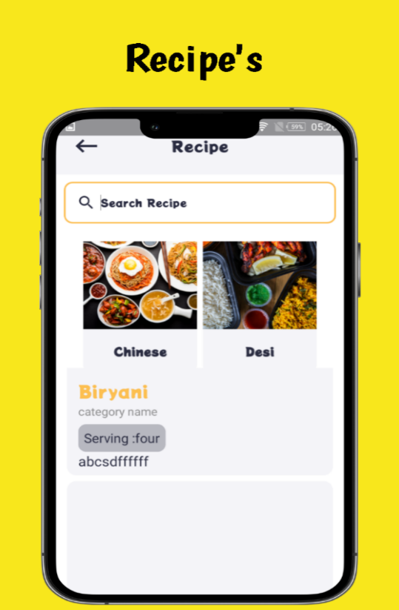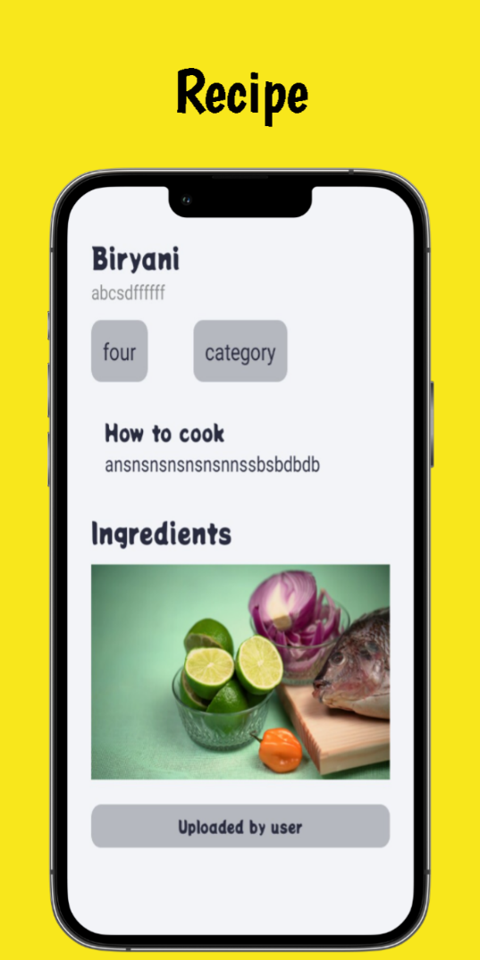

**This screen navigate when user click particular recipe to show recipe details.**

**Recipe Screen where you can see all recipe in our app.**

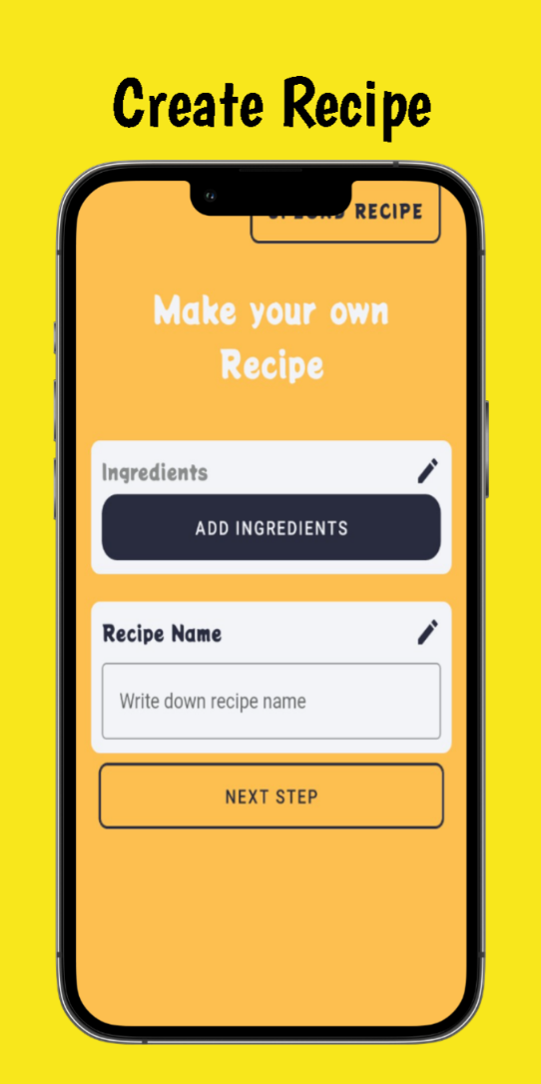

**User can upload recipe..**